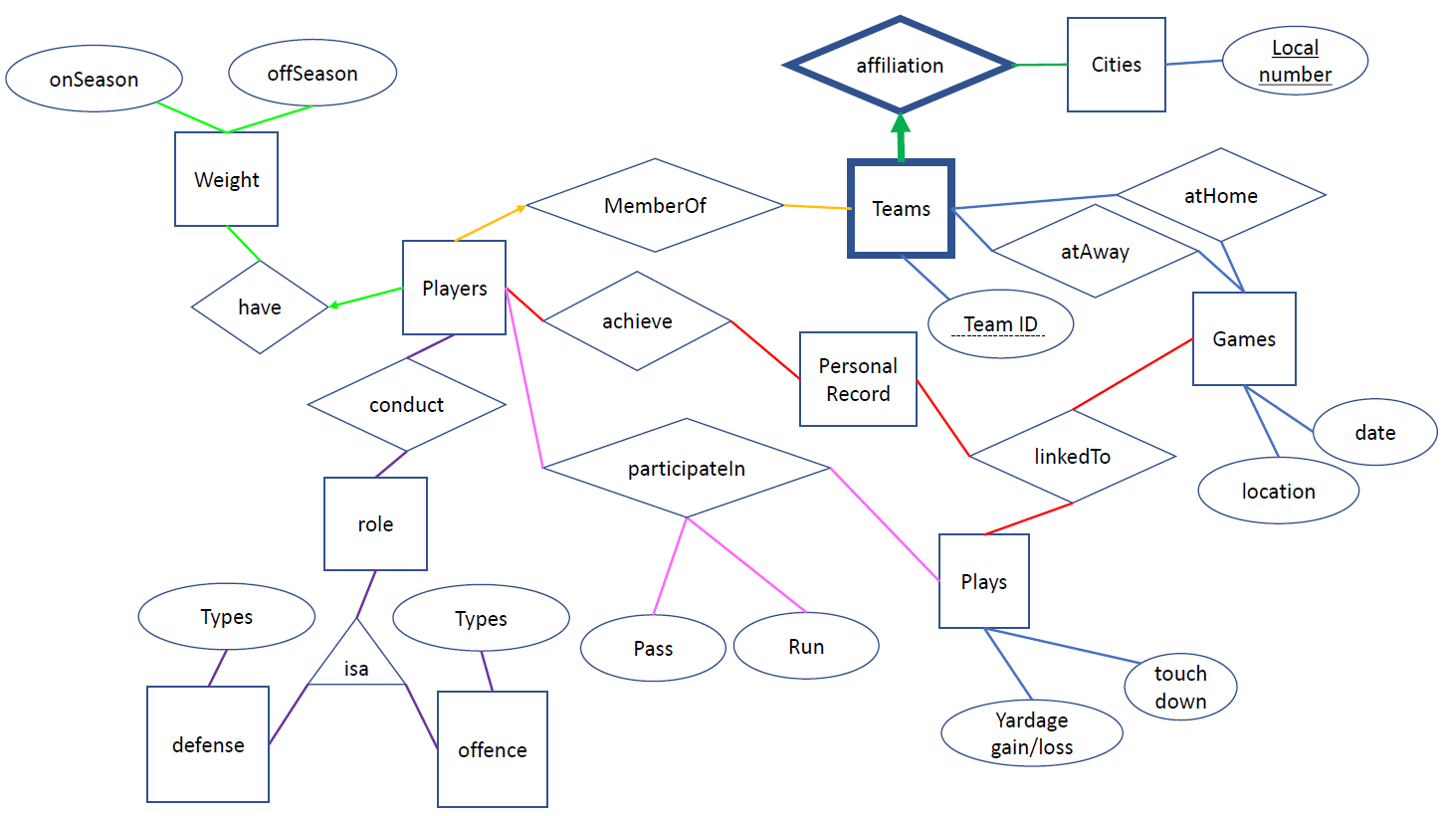

E/R Diagram for football

21102052 Lee Jeong-Yun

Explanation



1. Players-achieve-personal record-linkTo-Games & Plays

‘achieve’ relationship between ‘Players’ and ‘Personal Record’

‘Personal Record’, ‘Plays’, and ‘Games’ are connected by ‘linkedTo’ multiple relationships.

‘Personal Record’ is achieved by ‘Players’

‘Personal Record’ is linked to ‘Plays’ and ‘Games’

* ‘Personal Record’ is an entity set, not an attribute because of its network.

1. Players-have-weight-onSeason & offSeason

‘Players’ ‘weight’ is constantly maintained during each period, ‘onSeason’ & ‘offSeason’

‘onSeason’ and ‘offSeason’ can be different. ‘weight’ needs to have divided into two attributes, ‘onSeason’ and ‘offSeason’.

‘Players’ only can have one ‘weight’. But many ‘Players’ are available to have the same ‘weight.’ -> many-to-one relationship in ‘have’ relationship between ‘Players’ and ‘weight’.



1. Players-memberOf-Teams

‘Players’ belongs to ‘Teams’.

Each ‘Players’ should join just one team in ‘Teams’.

Each ‘Teams’ can own many ‘Players’ without ‘Players’ redundancy.

Many-to-one relationship in ‘MemberOf’ relationship between ‘Players’ and ‘Teams’.

1. Teams-affiliation-Cities

The weak entity is ‘Teams’. Because ‘Team ID’ is depending on ‘Local number’.

The relationship, ‘affiliation’ should be participated in totally. Because ‘Teams’ key is came from ‘Cities’ key, ‘Local number’.

Many ‘Teams’ can be in one ‘City’. One team cannot be in many cities. There is a many-to-one relationship between ‘Teams’ and ‘Cities’.



1. Players-conduct-role-isa-defense & offence-type

Many ‘Players’ can ‘conduct’ multiple ‘roles’ in their sports.

The role of football is divided by defense and offense. Both roles share some common properties, but they are not the same. So, in this case, the subclass(isa) can be a solution.

Each role has certain types or positions in the field. So, they have type attributes respectively.

1. Players-participatein-plays

‘Players’ do not always do ‘Pass’ or ‘Run’.

‘Plays’ requires ‘Players’ to do ‘Pass’ and ‘Run’.

When ‘Players’ participates in the ‘Plays’, ‘Pass’ and ‘Run’ can be done. So, ‘Pass’ and ‘Run’ are attributes of a relationship, ‘participatein’.